COCOS 2D X

- cocos2d is an open source software framework which can be used to build games, apps and other cross platform GUI (Graphical User Interface)based interactive programs.
- Cocos2d contains many branches with the best known being Cocos2d-objc, Cocos2d-x, Cocos2d-html5 and Cocos2d-XNA.
- There are some independent editors in the cocos2d community, such as those contributing in the areas of SpriteSheet editing, particle editing, font editing and Tilemap editing as well as world editors including SpriteBuilder and CocoStudio

COCOS 2DX:

- One of the branches of cocos2d is cocos2dx which is a cross-platform game engine that provides a simplified API for developing cross-platforn mobile and desktop games.
- Cocos2dx is a multiframewok for building 2d games,interactive books,demos and other graphical applications.
- It is based on cocos2d-iphone,but instead of using objective-c,it uses C++ .It works on ios, Android,windows phone and store apps,OS X,windows,Linux and other web platforms.

Functional features:
- Scene Management
- 2D Graphics
  - OpenGL ES 2.0 (mobile) / OpenGL 2.1 (desktop) based
  - Transitions between scenes
  - Sprites and Sprite Sheets
  - Effects: Lens, Ripple, Waves, Liquid, etc.
  - Transformation Actions: Move, Rotate, Scale, Fade, Tint, etc.
  - Composable actions: Sequence, Spawn, Repeat, Reverse
  - Ease Actions: Exp, Sin, Cubic, Elastic, etc.
  - Misc actions: CallFunc, OrbitCamera, Follow, Tween
  - Basic menus and buttons
  - Particle system
  - Skeleton Animations: Spine and Adobe DragonBone
  - Fonts:
    - Fast font rendering using Fixed and Variable width fonts
    - Support for .ttf fonts
  - Tile Map support: Orthogonal, Isometric and Hexagonal
  - Parallax scrolling
  - Motion Streak
  - Render To Texture
  - Touch/Accelerometer on mobile devices
  - Touch/Mouse/Keyboard on desktop
  - Sound Engine support (CocosDenshion library) based on OpenAL
  - Integrated Slow motion/Fast forward
  - Fast and compressed textures:
    - PVR compressed and uncompressed textures
    - ETC1 compressed textures, and more
  - Resolution Independence
- UI Widgets
  - Horizontal and Vertical layout
  - Containers: List View, Page View, Scroll View
  - Widgets: Button, Check Box, Loading Bar, Slider, Text Field
- Physics
  - Integrated Chipmunk2D inside
  - A easy-to-use object-orientated wrapper with body, contact, joint, shape concepts
- Audio
  - Sound effects
  - Background Music
- Network
  - HTTP with SSL
  - Web Socket API
  - XML Http Request API

Non-functional features:
- Cocos2d is:
- > Fast
-> Free
-> Easy to use
-> Community supported

Architectural design:
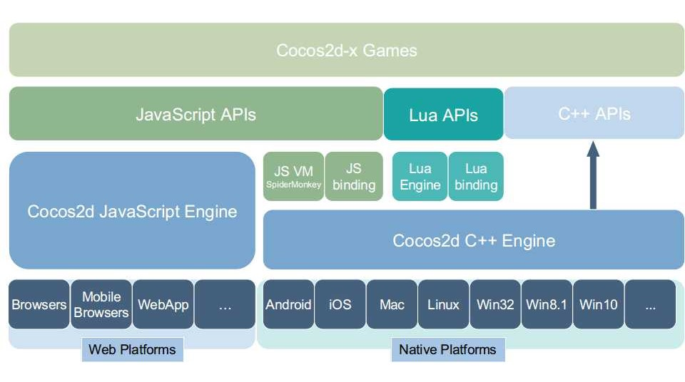

MVC pattern for cocos2dx projects:

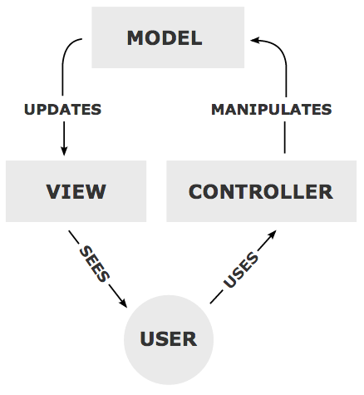

The model
Model represents a game logic. I am building a platform game so I will keep my examples based on actual implementation. My model contains the following classes (just some of them):
- Player,
  - Contains properties such as: player position, player current velocity (in X / Y axes), etc.
  - Contains methods that execute domain logic on a player, such as run, walk, jump, etc.
  - Contains a method called update that is executed in a main game loop and is responsible for updating a player model in time.
- Platform,
  - Contains properties such as: platform position, platform width, platform height, etc.
  - Contains methods that execute domain logic on a platform, such as collapse,
  - Contains a method called update that is executed in a main game loop and is responsible for updating a platform in time.
- Game Model,
  - Contains properties that describe a world all other objects live in, such as current gravity,
  - Contains methods that execute domain logic on a game model,
  - Contains a method called update that is executed in a main game loop and is responsible for updating a game world properties but also trigger update on the other objects that live in a game world.

* Model uses different units than pixels which better reflect the reality of a real world – in a model I am using meters but you can also use inches or any others you prefer. * Model is completely unaware of a rendering engine that you are going to use later on.

The view
- According to MVC principle the view should be only responsible for a presentation. It’s actually the easiest part of MVC in cocos2d. If we have a model,we can just render it by CC Layer using CC Sprite or other Cocos2d classes. The benefit of having a model separated from a view is that you don’t need to map properties of a model directly to view properties, for example if our player is changing your position in X axis, but we want to keep it always 10 px from the left of a screen, instead of moving a player’s sprite we would just rather move a whole CC Layer instead.
- When rendering model objects into view,we need to remember about the units, if we are using meters,we should remember to convert it to pixels.
-> How does our model take the view?
- We can either pass it from the controller when a view is created or we can create a game model as a singleton and access it using a static method.

The controller
- The controller ties everything together and its main responsibility is a user input handling. Since we need to instantiate a model and a view somewhere we find it best to do it in a controller.
- we also implement our controller as a subclass of CC Scene and we have our initial controller instantiated by my application delegate class. There is however one problem here that touches are handled by the CC Layer class which in my approach is a view because we don’t want a view to be responsible for handling user input and we need to pass a view a reference to a controller (not directly, but as a delegate) and execute controller method (through a delegate) from a touch handler in view. And that’s it our controller is now fully responsible for handling a touch event from a view and modify a model accordingly (either by updating model properties or by executing model methods). After the model is modified, the view needs to be updated as well. We can do it in our game loop, which is implemented by a controller.
- So,The responsibility of a controller is just to execute an update method on a view, and the view will do the rest.

